# CS 255 System Design Document Template

## UML Diagrams

### UML Use Case Diagram

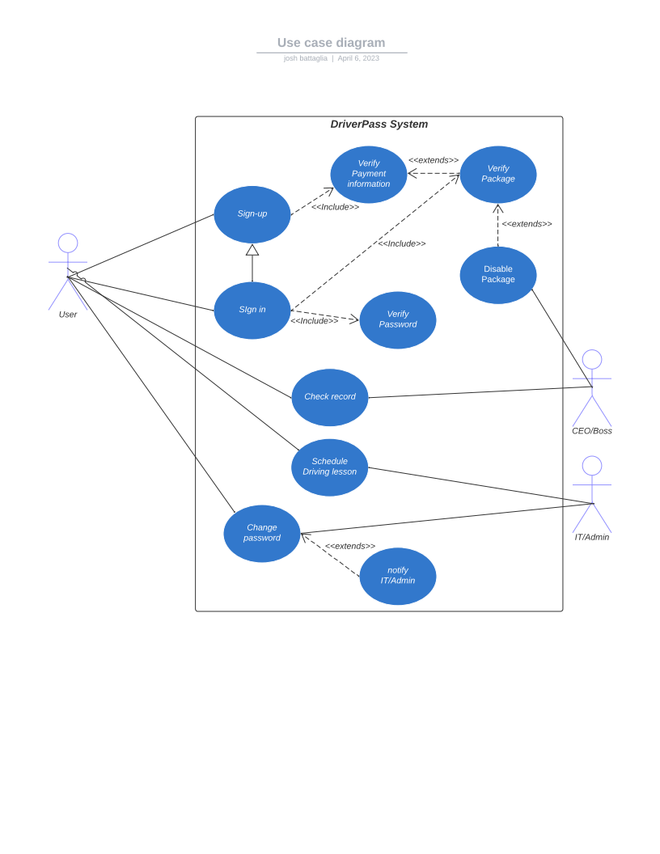

### UML Activity Diagrams

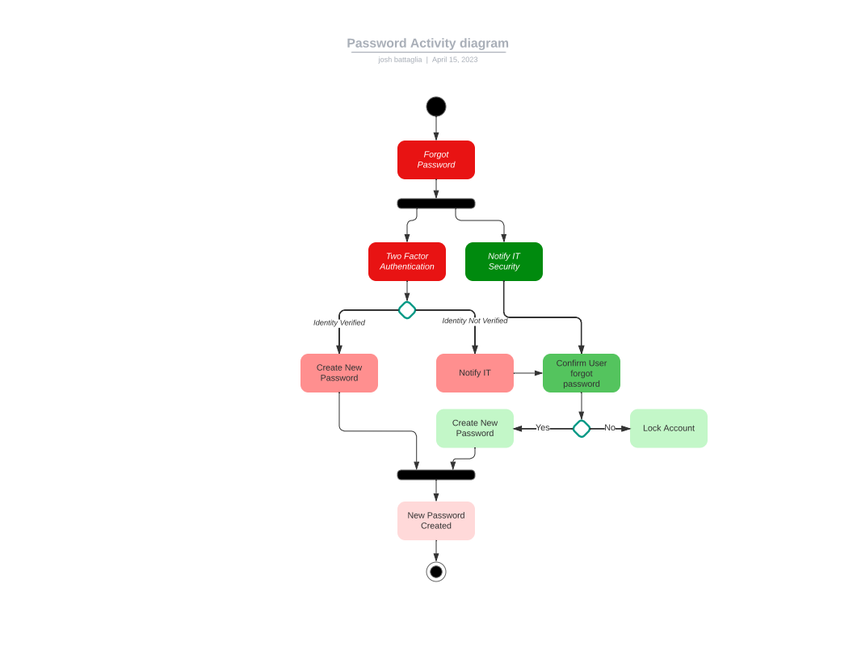

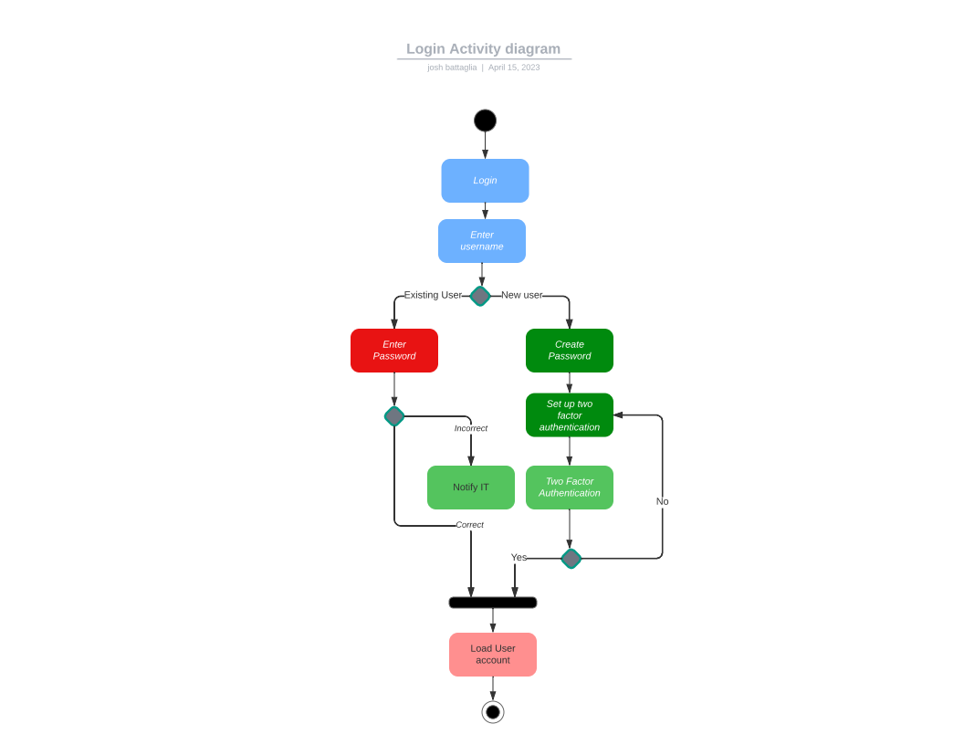

### UML Sequence Diagram

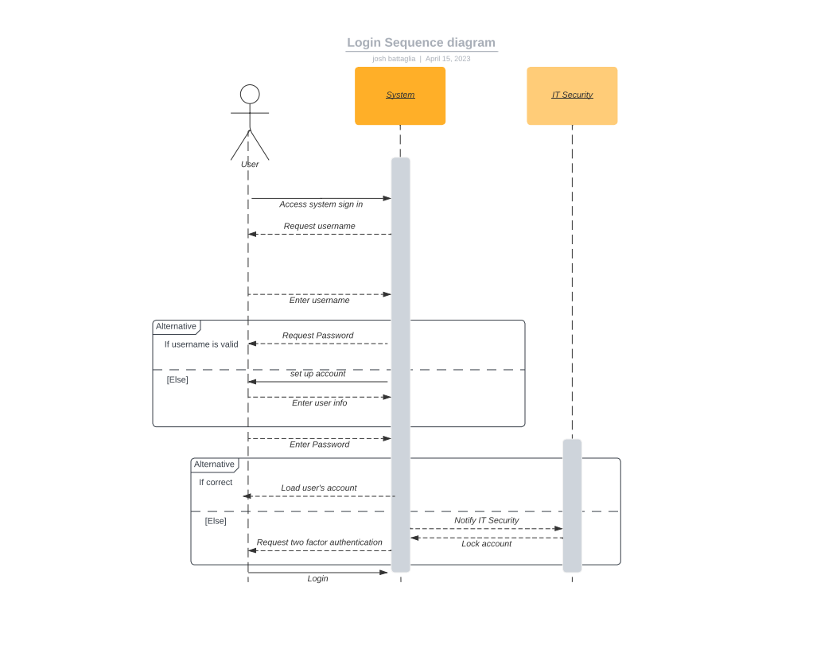

### UML Class Diagram

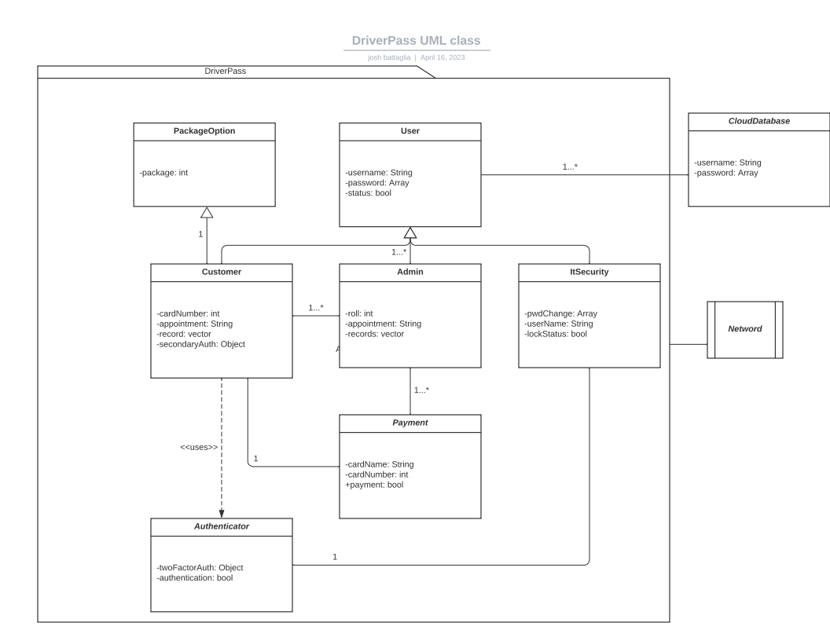

## Technical Requirements

*DriverPass wants a system that can be accessed from anywhere quickly and securely. This required a system that can be access from the internet on any device. The system uses an external database to store usernames, and passwords. There is also an interface with banking to confirm payment, and payment information. In our system we used a cloud database to be cost effective. Admin privileges provide admin users to access student (customer) records and store them. It also allows admin to schedule an appointment on a customer’s behalf, and lock package options. Security has full access to the system including the ability to change passwords, and lock accounts. The system is a packaged application that is accessed from a server, which allows potability.*